Project Design Phase
Solution Architecture
Date | 15 February 2025
Team ID | SWTID-2026-8514
Project Name | Implement Client Script & UI Policy (Incident)
Maximum Marks | 4 Marks

Solution Architecture:
Solution architecture is a complex process – with many sub-processes – that bridges the gap between business problems and technology solutions. Its goals are to:
- Find the best tech solution to solve existing business problems.
- Describe the structure, characteristics, behavior, and other aspects of the software to project stakeholders.
- Define features, development phases, and solution requirements.
- Provide specifications according to which the solution is defined, managed, and delivered.
Example - Solution Architecture Diagram:
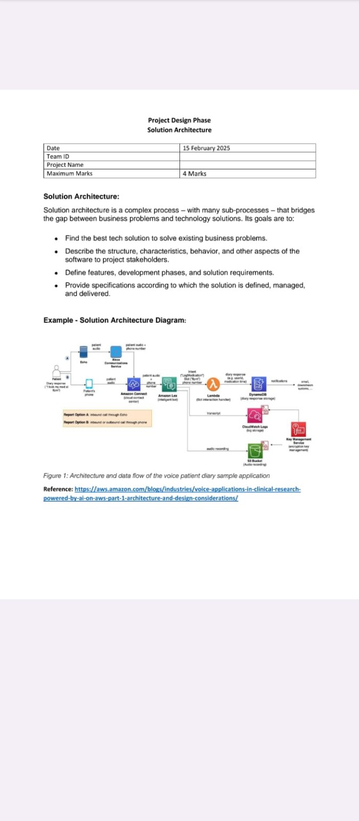
Figure 1: Architecture and data flow of the voice patient diary sample application
Reference: https://aws.amazon.com/blogs/industries/voice-applications-in-clinical-research-powered-by-ai-on-aws-part-1-architecture-and-design-considerations/
Team Members
Role | Name
Team Leader | DHIVYA DHARSHINI R
Team member | DIVYALAKSHMI R
Team member | GAYATHRI S
Team member | GUNASUNDARI SIVAKUMAR
Team member | HARINI M

